Hibernate Tutorial

What is JPA? Introduction to the Java Persistence API

Hibernate TutorialThe Java ORM standard for storing, accessing, and managing Java objects in a relational database

JPA is not a tool or framework; rather, it defines a set of concepts that can be implemented by any tool or framework.

While JPA's object-relational mapping (ORM) model was originally based on Hibernate,

JPA and Hibernate

What is Java ORM?
every JPA implementation provides some kind of ORM layer

In Java, the ORM layer converts Java classes and objects so that they can be stored and managed in a relational database.

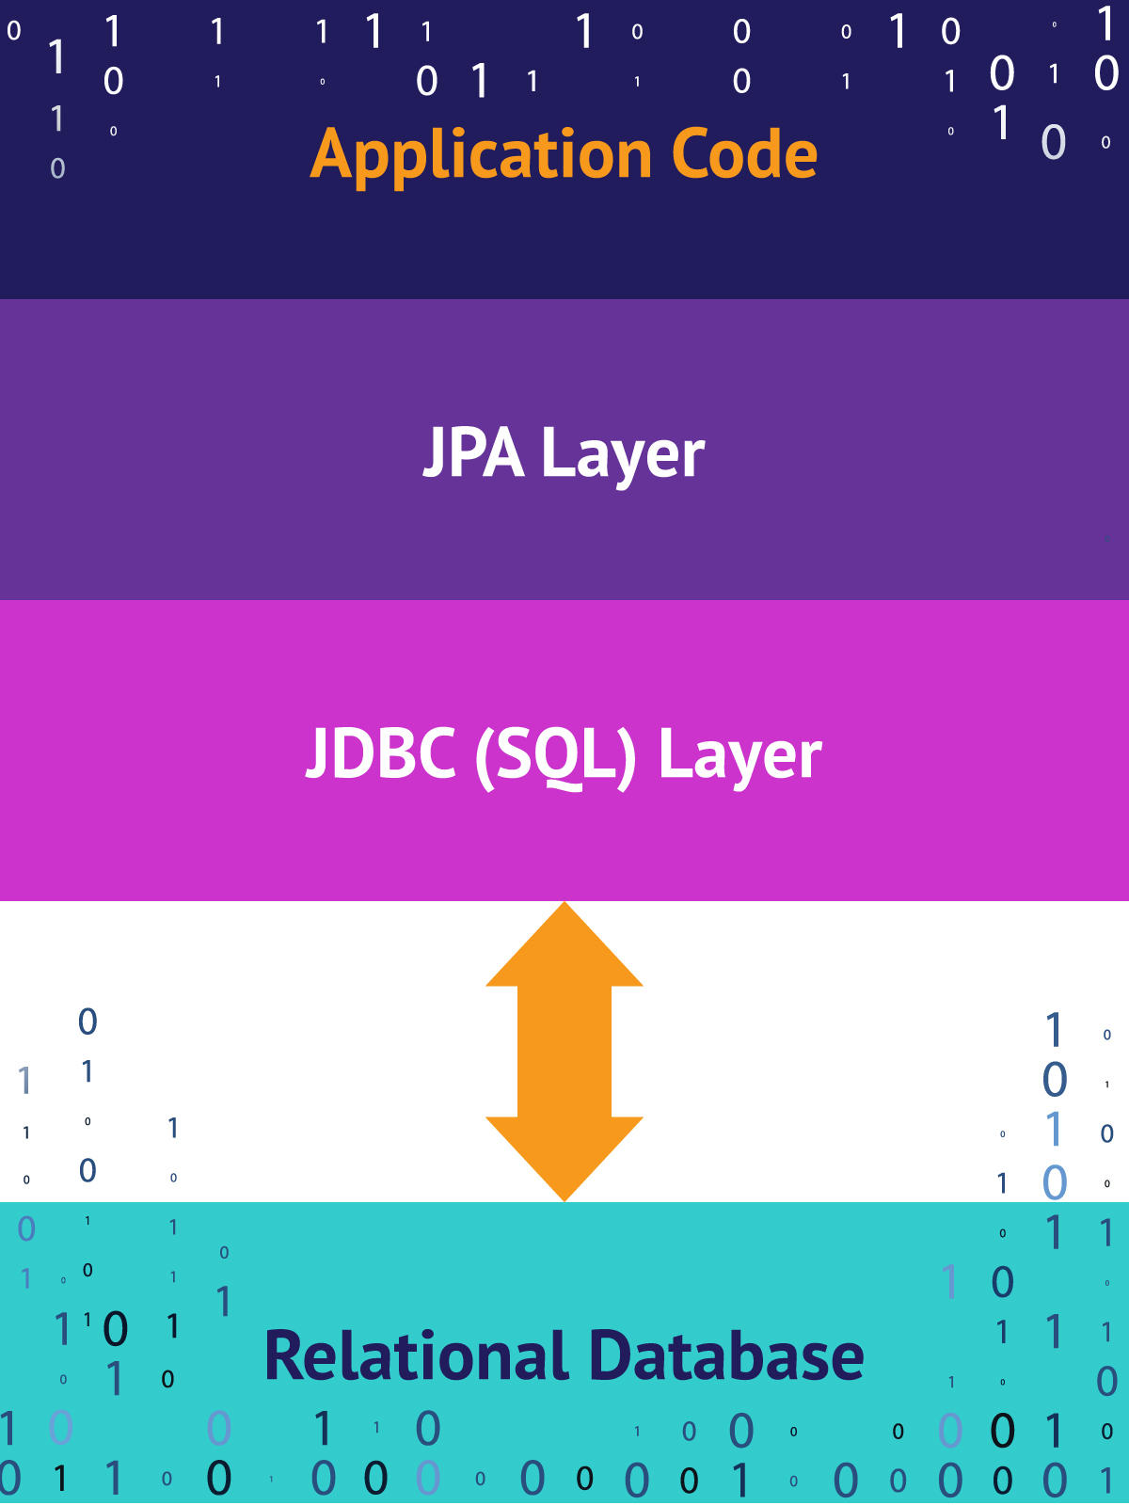

Hibernate Tutorial

Hibernate is an open source Java persistence framework project. It performs powerful object-relational mapping and query databases using HQL and SQL.

Hibernate is a great tool for ORM mappings in Java.

Query
Query refers to JPQL/HQL query with syntax similar to SQL generally used to execute DML statements(CRUD operations).
In JPA, you can create a query using entityManager.createQuery(). You can look into APIfor more detail.
In Hibernate, you use session.createQuery()"

NativeQuery
Native query refers to actual sql queries (referring to actual database objects). These queries are the sql statements which can be directly executed in database using a database client.
JPA : entityManager.createNativeQuery() Hibernate (Non-JPA implementation): session.createSQLQuery()
NamedQuery
Similar to how the constant is defined. NamedQuery is the way you define your query by giving it a name. You could define this in mapping file in hibernate or also using annotations at entity level.
TypedQuery
TypedQuery gives you an option to mention the type of entity when you create a query and therefore any operation thereafter does not need an explicit cast to the intended type. Whereas the normal Query API does not return the exact type of Object you expect and you need to cast.

One to Many bi – directional Many to one

@Entity
@Table(name = "customer")
public class Customer {

@Id
@GeneratedValue(strategy = GenerationType.AUTO)
@Column(name = "id")
private int id;

@Column(name = "name")
private String name;

@OneToMany(mappedBy = "customer",cascade = CascadeType.ALL)
Set<PhoneNumber> numbers;

}

@Entity
@Table(name = "phone_number")
public class PhoneNumber {

@Id
@Column(name = "id")
int id;

@Column(name = "number")
String number;

@Column(name = "type")
String type;

@ManyToOne()
@JoinColumn(name = "customer_id")
Customer customer;

}

public interface CustomerRepository extends CrudRepository<Customer, Integer>{}

@SpringBootTest
public class CustomerTest {

@Autowired
CustomerRepository customerRepository;

@Test
public void insert() {

Customer customer = new Customer();
customer.setId(1);
customer.setName("sangam");
HashSet<PhoneNumber> hashSet = new HashSet<PhoneNumber>();

PhoneNumber number1 =new PhoneNumber();
number1.setId(1);
number1.setNumber("123");
number1.setType("home");
number1.setCustomer(customer);
hashSet.add(number1);

PhoneNumber number2 =new PhoneNumber();
number2.setId(2);
number2.setNumber("131");
number2.setType("cell");
number2.setCustomer(customer);
hashSet.add(number2);

customer.setNumbers(hashSet);
customerRepository.save(customer);

}
}

Lazy/Eager Loading Tutorial

Hibernate lazy loading :

Refer to strategy when data is loaded lazily, on demand.

Eager Loadin
are fetched fully at the time their parent is fetched.

LAZY = fetch when needed
EAGER = fetch immediately

Hibernate Lazy Loading Tutorial

In any application, hibernate fetches data from databse either in eager or lazy mode. Hibernate lazy loading refer to strategy when data is loaded lazily, on demand.

1. Hibernate lazy loading – why we need it?

Consider one of common Internet web application: the online store.

The store maintains a catalog of products.

At the crudest level, this can be modeled as a catalog entity managing a series of product entities

In a large store, there may be tens of thousands of products grouped into various overlapping categories.

- When a customer visits the store, the catalog must be loaded from the database
- We probably don’t want the implementation to load every single one of the entities representing the tens of thousands of products to be loaded into memory.
- Even if this was possible, it would probably cripple the performance of the site
- Only when the user drills down into the categories should a subset of the products in that category be loaded from the database.

2. How lazy loading solve above problem

Now when we have understood the problem, let’s understand how lazy loading actually helps in real life. If we consider to solve the problem discussed above then we would be accessing a category (or catalog) in below manner:
//Following code loads only a single category from the database:
Category category = (Category)session.get(Category.class,new Integer(42));
However, if all products of this category are accessed, and lazy loading is in effect, the products are pulled from the database as needed. For instance, in the following snippet, the associated product objects will be loaded since it is explicitly referenced in second line.
//Following code loads only a single category from the database
Category category = (Category)session.get(Category.class,new Integer(42));

//This code will fetch all products for category 42 from database - "NOW"
Set<Product> products = category.getProducts();
This solve our problem of loading the products only when they are needed.

